AI-Enabled Student Admissions &
Support Management System
Enterprise Engineering Blueprint & Core System Documentation

Project Overview
The AI-Enabled Student Admissions & Support Management System is a Salesforce-based enrollment platform built to centralize and intelligently manage the complete student admissions lifecycle — from initial application and counselor review, through discount and approval handling, to final enrollment confirmation.
The system brings student records, course inventory, enrollment applications, counselor activities, approval workflows, and AI-generated risk insights together into a single administrative workspace. Built entirely with Salesforce Admin capabilities — custom objects, Record-Triggered Flows, validation rules, approval-style governance, and Einstein Prompt Builder — the application removes the friction of manually tracking discount exceptions and inconsistent enrollment decisions.
Counselors can view AI-generated priority scores and risk summaries directly on each enrollment record, while institutional staff can rely on automated reminders and grounded AI recommendations instead of chasing down spreadsheets. The result is a faster, more consistent, and more transparent admissions process that scales with the institution's intake volume while keeping student data secure and well-governed.

Objectives

Centralized Admissions Management
Provide a single Salesforce platform to manage:
- Student records
- Course inventory
- Enrollment applications
- Discount and approval tracking
- AI-generated risk and priority insights

Automation of Admissions Workflows
Streamline:
- Enrollment data capture and validation
- Discount escalation and approval routing
- Counselor follow-up reminders
- Status and priority updates

AI-Driven Risk Intelligence
Enable:
- AI-generated priority scoring
- Automated risk-level classification
- Grounded enrollment summaries
- Actionable counselor recommendations

Security & Governance
Ensure:
- Controlled, field-level access to sensitive student data
- Hard validation gates on discount and approval logic
- Clean, duplicate-free student and course records

Phase 1: Requirement Analysis and Planning

Understanding Business Requirements
Educational institutions typically process a steady stream of student applications through spreadsheets, email threads, and disconnected intake forms. This approach commonly leads to duplicate student records, missed follow-ups, inconsistent discount approvals, and very little visibility into which applications actually need attention.
The business requires a centralized, CRM-based admissions system that can:
- Track every student enrollment in one place
- Standardize discount validation and approval logic
- Automate counselor notifications and follow-ups
- Provide AI-grounded risk summaries for faster decisions
- Protect sensitive fields such as the AI Priority Score from manual tampering
Salesforce was selected as the platform of choice because it offers secure cloud infrastructure, mature declarative automation tools (Flow), native duplicate management, and Einstein Prompt Builder for safely grounding generative AI against real, permissioned student data.

Defining Project Scope and Objectives
Project Scope
The project covers building the admissions system entirely with Salesforce Admin tools — custom objects, fields, validation rules, duplicate management, Record-Triggered Flows, a Screen Flow intake wizard, and Einstein Prompt Builder — without any custom Apex development.
The application supports the full admissions lifecycle:
Student → Application → Discount Review → Approval → Enrollment
Objectives
- Implement Salesforce CRM fundamentals for student admissions
- Create a scalable, relationally sound enrollment data model
- Apply field-level and record-level security throughout
- Automate discount, approval, and follow-up workflows using Flow
- Use Einstein Prompt Builder for grounded AI risk summaries
- Enable clean, duplicate-free enrollment record-keeping

Phase 2: Salesforce Development – Backend & Configuration

Milestone 1: Custom Data Model Architecture & Relational Design
To keep the database clean and layout-compliant, a custom configuration baseline was established on top of Salesforce's standard CRM layers, starting with the two core custom objects that anchor the entire system.
Activity 1: Creating the Student Enrollment Object
- From the Setup page, click on Object Manager.
- Click on Create ≫ Custom Object.
- Enter the Label as Student Enrollment.
- Enter the Plural Label as Student Enrollments.
- Enter the Record Name as Student Enrollment Name.
- Select Data Type: Auto Number — ENR-{0000}, Starting Number: 1.
- Select Allow Reports.
- Select Allow Search.
- Enable Track Field History.
- Click Save.
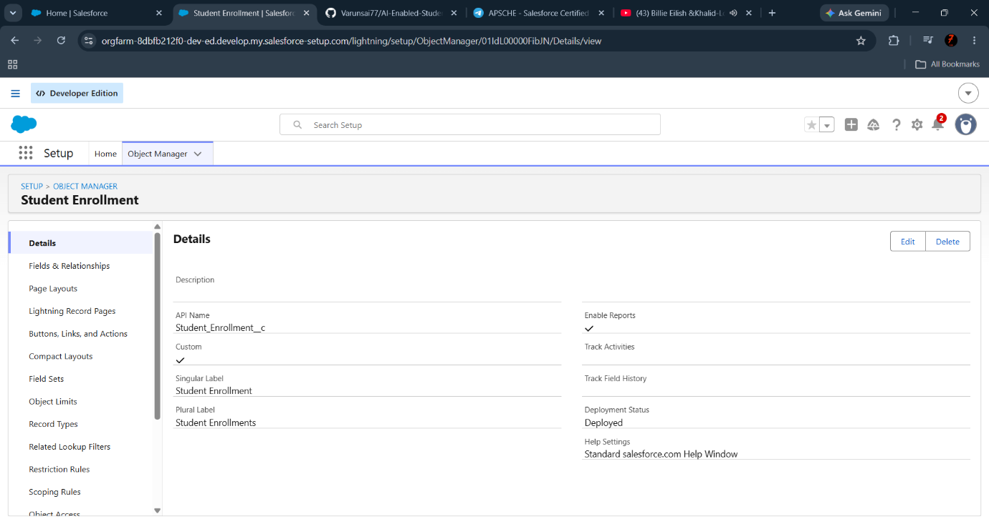
Student Enrollment custom object configuration
Activity 2: Creating the Course Object
To establish a clean relational anchor for academic tracking, a supporting Course object was configured to act as the master lookup source that every enrollment record ties back to.
- From the Setup page, click on Object Manager.
- Click on Create ≫ Custom Object.
- Enter the Label as Course.
- Enter the Plural Label as Courses.
- Enter the Record Name as Course Name (Text).
- Select Allow Reports and Allow Search.
- Enable Track Field History.
- Click Save.
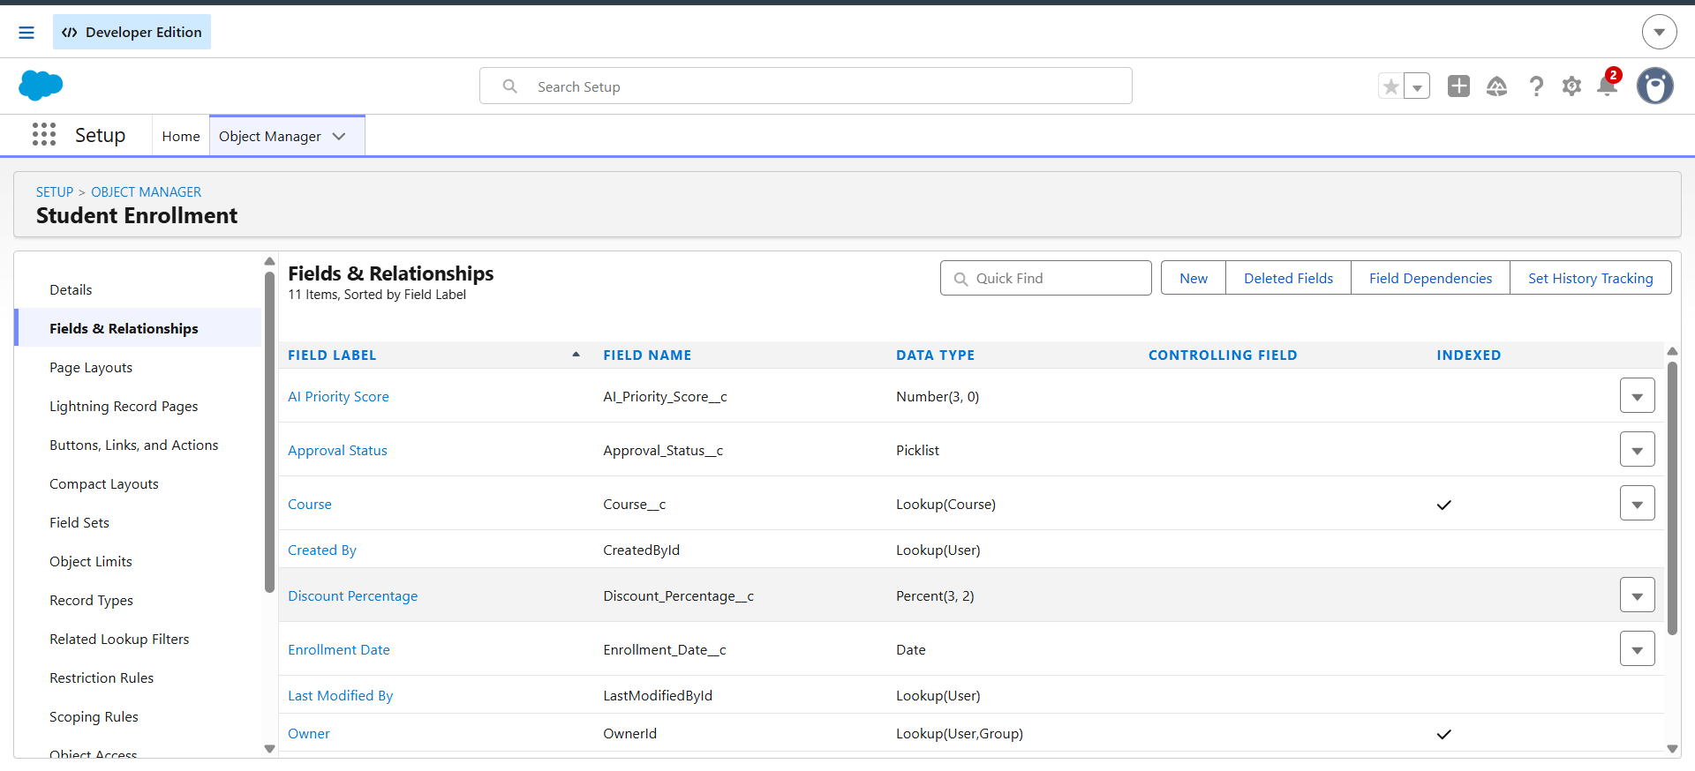
Course custom object setup

Milestone 2: Fields & Relationships
The database schema uses lookups, precise numeric percent allocations, and secure picklists to enforce consistent data tracking across every enrollment record.
Object | Field Name | Data Type | Required
Student Enrollment | Student (Student__c) | Lookup (Contact) | Yes
Student Enrollment | Course (Course__c) | Lookup (Course) | Yes
Student Enrollment | Enrollment Date (Enrollment_Date__c) | Date | Yes
Student Enrollment | Discount Percentage (Discount_Percentage__c) | Percent (3,2) | Yes
Student Enrollment | AI Priority Score (AI_Priority_Score__c) | Number (3,0) | Yes
Student Enrollment | Risk Level (Risk_Level__c) | Picklist (Low, Medium, High) | Yes
Student Enrollment | Approval Status (Approval_Status__c) | Picklist (Pending, Approved, Rejected) | Yes

Activity 1: Creating the Student Lookup Field
- Go to Setup ≫ Object Manager ≫ Student Enrollment.
- Click on Fields & Relationships ≫ New.
- Select Data Type as Lookup Relationship and click Next.
- Select the related object as Contact.
- Enter the Field Label as Student.
- Click Next, Next, Next, and Save.
Activity 2: Creating the Discount Percentage Field
- Go to Setup ≫ Object Manager ≫ Student Enrollment.
- Click on Fields & Relationships ≫ New.
- Select Data Type as Percent and click Next.
- Enter the Field Label as Discount Percentage.
- Set Length as 3 and Decimal Places as 2.
- Click Next, Next, and Save.
Activity 3: Creating the Risk Level Picklist Field
- Go to Setup ≫ Object Manager ≫ Student Enrollment.
- Click on Fields & Relationships ≫ New.
- Select Data Type as Picklist and click Next.
- Enter the Field Label as Risk Level.
- Click on Enter values and enter: Low, Medium, High.
- Click Next, Next, and Save.
[ Insert your screenshot showing the Fields & Relationships list view part 1 here ]
[ Insert your screenshot showing the Fields & Relationships list view part 2 here ]

Milestone 3: Validation Rules
To keep the system fully audit-compliant and protected against erroneous manual input, strict server-side validation rules are enforced on the Student Enrollment object.
Activity 1: Valid_Discount_Range
- Go to Setup ≫ Object Manager ≫ Student Enrollment.
- Click on Validation Rules ≫ New.
- Enter the Rule Name as Valid_Discount_Range.
- Select Active.
Insert the Error Condition Formula as:
OR(Discount_Percentage__c < 0, Discount_Percentage__c > 1.00)
- Enter the Error Message as “Discount percentage must be between 0% and 100%.”
- Select the Error Location as Top of the Page.
- Click Save.
This rule hard-locks data entry so the system can never accept a negative discount value or an amount exceeding 100%.
Activity 2: High_Discount_Requires_Approval
- Go to Setup ≫ Object Manager ≫ Student Enrollment.
- Click on Validation Rules ≫ New.
- Enter the Rule Name as High_Discount_Requires_Approval.
- Select Active.
Insert the Error Condition Formula as:
AND(Discount_Percentage__c > 0.20, ISPICKVAL(Approval_Status__c, "Draft"))
- Enter the Error Message as “Discounts above 20% must be reviewed and approved before saving.”
- Select the Error Location as Top of the Page.
- Click Save.
This rule acts as a financial guardrail: if a discount exceeds the standard 20% limit while the record is still unreviewed, the save transaction is blocked and the counselor is instructed to escalate to management.
Activity 3: Lock_AI_Priority_Score
- Go to Setup ≫ Object Manager ≫ Student Enrollment.
- Click on Validation Rules ≫ New.
- Enter the Rule Name as Lock_AI_Priority_Score.
- Select Active.
- Configure the formula to reject manual changes to AI_Priority_Score__c outside of automation context.
- Enter an appropriate Error Message explaining the field is system-managed.
- Click Save.
This rule ensures the AI Priority Score stays untampered with by rejecting manual field changes.
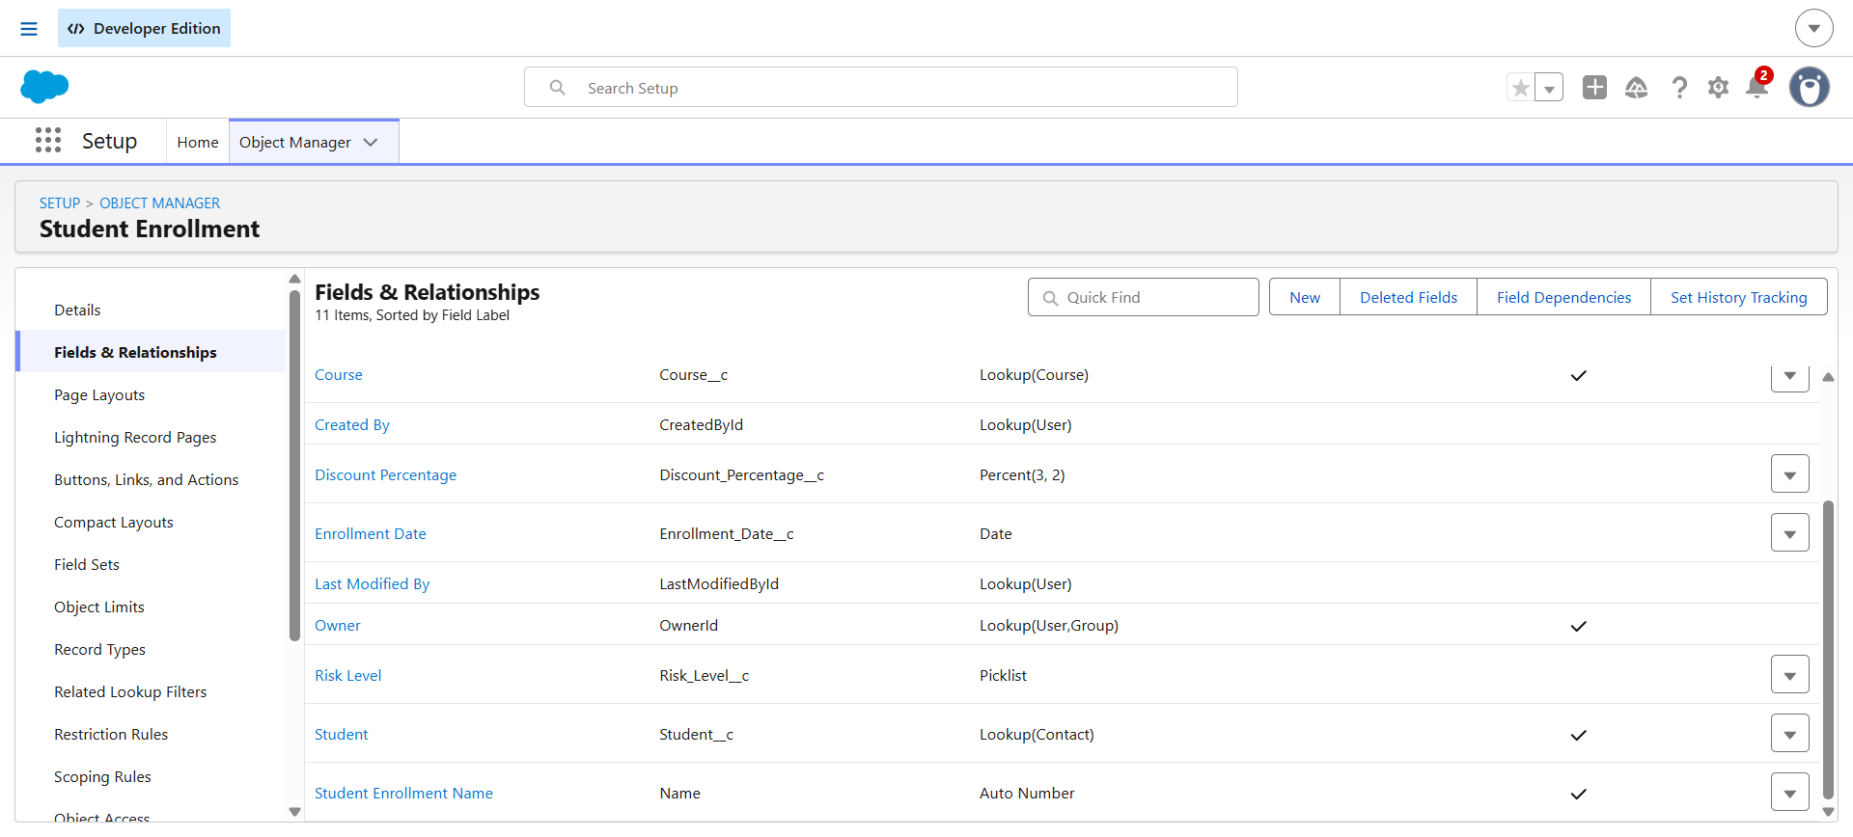
Validation rules configured on the Student Enrollment object

Milestone 4: Duplicate and Matching Rules
This milestone protects data integrity across the admissions system by preventing duplicate student (Contact) records and duplicate enrollment applications — which matters directly for reliable AI risk scoring, accurate approvals, and clean reporting.
Activity 1: Custom Matching Rule for Student (Contact)
- Go to Setup and search for Matching Rules.
- Click New Rule.
- Select Object: Contact, and click Next.
- Enter the Rule Name: Unique Student – Email & Phone.
- In Matching Criteria, set Field: Email → Matching Method: Exact.
- Add Field: Phone → Matching Method: Exact.
- Check Match Blank Fields.
- Click Next, then Save & Activate.
Activity 2: Duplicate Rule for Student (Contact)
- Go to Setup and search for Duplicate Rules.
- Click New Rule and select Object: Contact.
- Enter the Rule Name: Unique Student Email and Phone.
- Set Action on Create and Action on Edit to Allow and Report.
- Enter the Alert Text: “Student email and phone number must be unique.”
- Under Matching Rules, click Add Rule and select the previously created matching rule.
- Click Save & Activate.
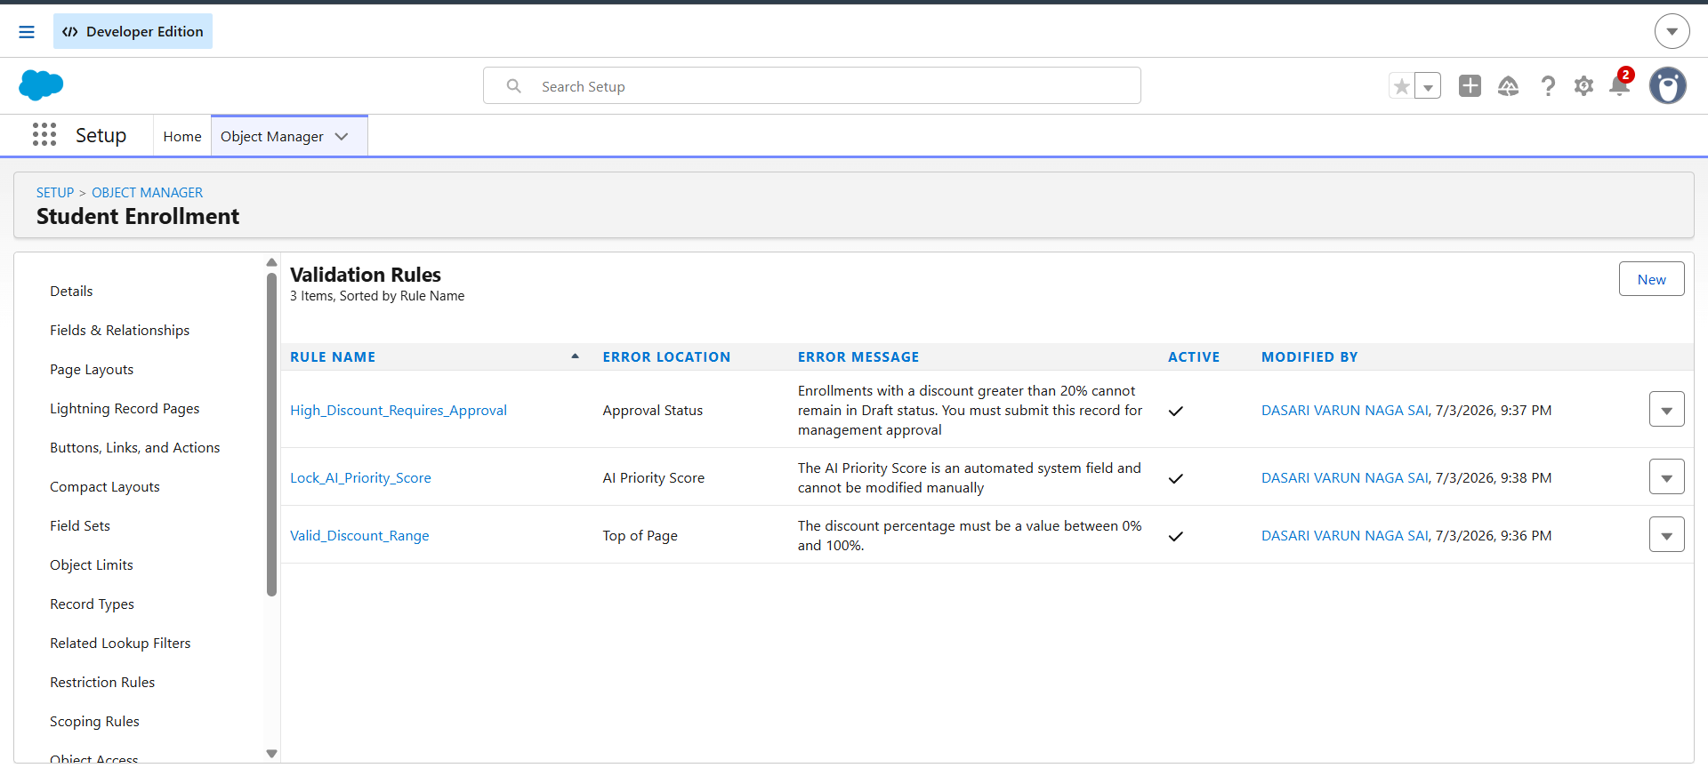
Duplicate and matching rule configuration for student records

Milestone 5: Declarative Process Automation (Flow Canvas)
Complex business logic is separated into isolated, declarative flows so back-end processing stays decoupled from the counselor-facing entry screens, keeping performance high and the system easy to maintain.
Platform Automation Overview
The system runs an end-to-end automation suite containing a full registry of active flows covering priority scoring, notifications, follow-up reminders, and guided data entry.
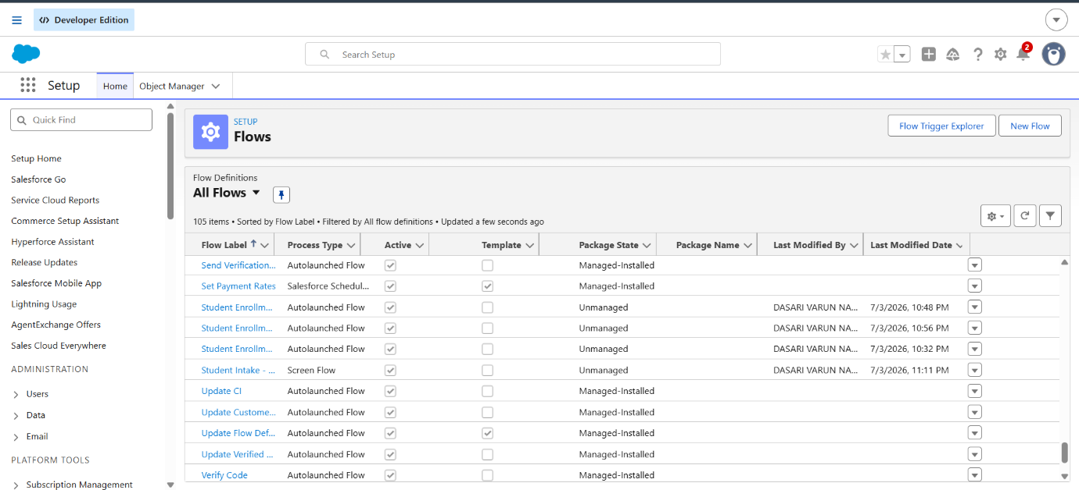
Registry of active Flows powering the admissions system
Activity 1: Before-Save Record-Triggered Flow – Priority and Risk Assignment
- From Setup, search for Flows and click New Flow.
- Select Category: Triggered, and Type: Record-Triggered Flow.
- Select Object: Student_Enrollment__c.
- Configure the trigger to run before the record is saved (Fast Field Updates).
- Add a Decision element: Check Priority Criteria, evaluating the incoming Discount Percentage and other risk factors.
- Add Assignment elements to write the correct value into AI_Priority_Score__c and Risk_Level__c.
- Save the Flow as “Student Enrollment – Priority and Risk Assignment” and Activate.
This flow triggers instantly on record creation or update. It parses the incoming fields, runs them through the Check Priority Criteria decision block, and writes the correct AI Priority Score and Risk Level onto the record before it ever reaches the database.
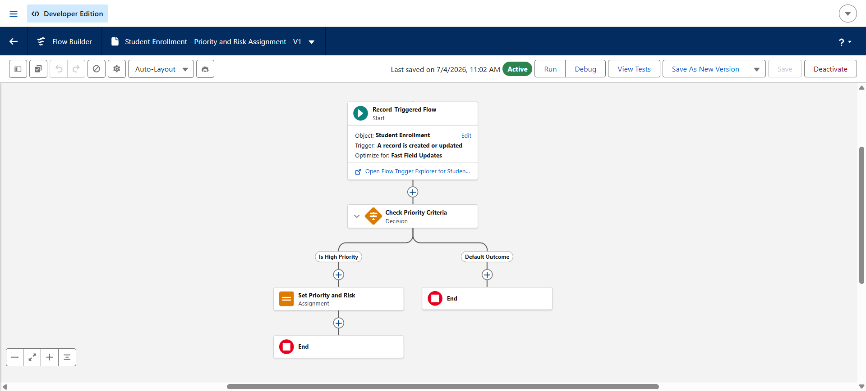
Before-Save Flow assigning priority score and risk level
Activity 2: After-Save Record-Triggered Flow – Automated Notifications
- From Setup, search for Flows and click New Flow.
- Select Category: Triggered, and Type: Record-Triggered Flow.
- Select Object: Student_Enrollment__c.
- Configure the trigger to run after the record is saved, optimized for Actions and Related Records.
- Add a Decision element to route based on Risk Level and Approval Status.
- Add Send Email Alert actions for welcome notifications and for high-priority supervisor escalation.
- Save the Flow as “Student Enrollment – Automated Notifications” and Activate.
This flow evaluates data immediately after a successful save. A conditional router chooses the correct communication path — either firing a welcome alert to the student or instantly routing high-priority exceptions to the supervisor queue.
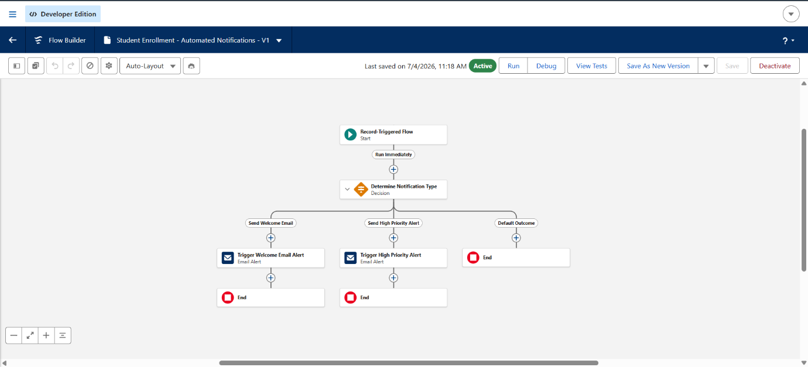
After-Save Flow routing welcome and escalation alerts
Activity 3: Scheduled-Triggered Flow – Daily Follow-up Reminders
- From Setup, search for Flows and click New Flow.
- Select Category: Triggered, and Type: Scheduled-Triggered Flow.
- Set the Start Date and Time, for example Today, 9:00 AM.
- Set the Frequency to Daily.
- Select Object: Student_Enrollment__c.
- Set the entry condition to find applications that have stalled in review for more than a set number of days.
- Add a Create Records element to generate a follow-up Task for the assigned counselor.
- Save the Flow as “Student Enrollment – Daily Follow up Reminders” and Activate.
This flow scans the database automatically every 24 hours for open applications that have stalled in processing, and automatically generates follow-up tasks to keep the admissions pipeline moving.
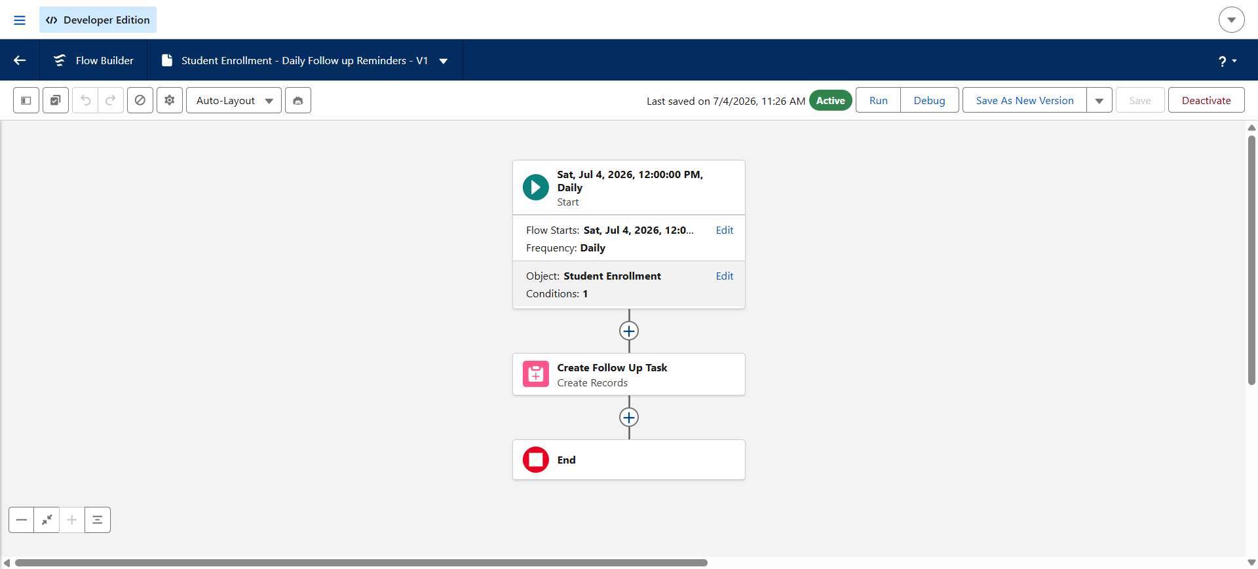
Scheduled Flow generating daily follow-up reminders
Activity 4: Screen Flow – Counselor Intake Wizard
- From Setup, search for Flows and click New Flow.
- Select Category: Screen Flow and click Create.
- Add a Screen element: Student Details, with fields for Student, Course, and Enrollment Date.
- Add a second Screen element: Discount Details, with fields for Discount Percentage and Approval Status.
- Add a Create Records element to create the Student_Enrollment__c record.
- Add a Confirmation Screen displaying “Enrollment Created Successfully.”
- Save the Flow as “Student Intake – Counselor Screen Flow.”
- Add the flow to the global Utility Bar so it sits directly inside the application's dock, and Activate.
This guided, step-by-step entry wizard standardizes counselor inputs, automatically maps them to the correct record fields, and lives directly inside the application's global utility dock for quick access.
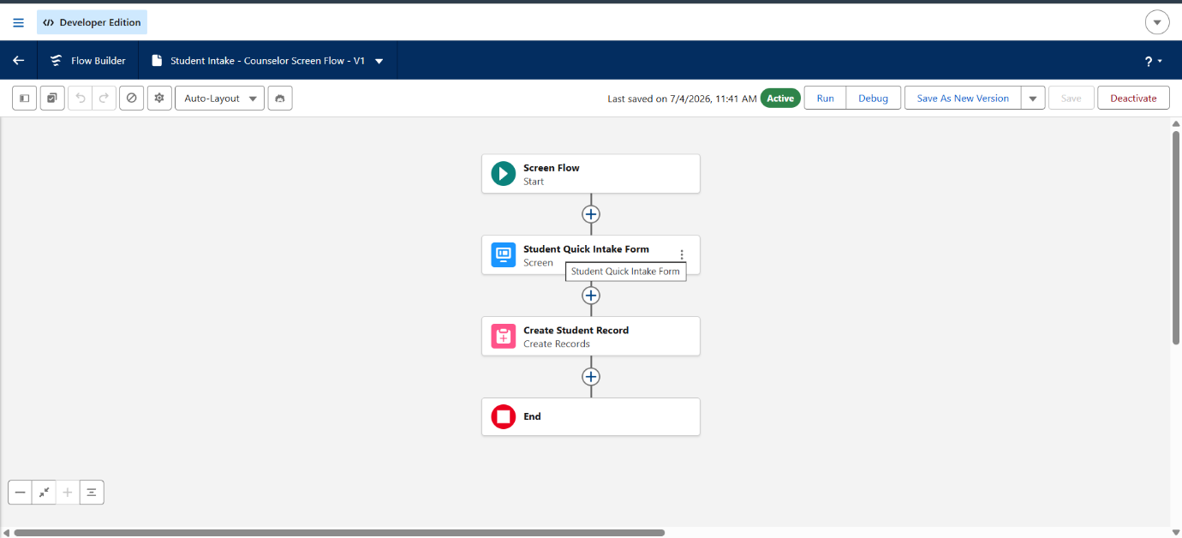
Screen Flow guiding counselors through student intake

Milestone 6: Einstein Generative AI Data Grounding
To safely summarize complex discount and risk variations without exposing protected student records to public large language models, the application implements an enterprise-grounded prompt pattern using Einstein Prompt Builder.
Activity 1: Creating the Enrollment Summary Prompt Template
- From Setup, search for Prompt Builder and click Prompt Builder.
- Click New Prompt Template.
- Select Prompt Type: Summary Prompt Template.
- Select the Grounding Object: Student_Enrollment__c.
- Enter the Prompt Name: Student Enrollment Risk Summary Prompt.
Enter the Prompt Content Payload:
You are an expert AI admissions risk assessor. Analyze the following student enrollment record data and provide a concise risk summary.
Student ID: {!Student_Enrollment.Name}
Priority Score: {!Student_Enrollment.AI_Priority_Score__c}
Discount applied: {!Student_Enrollment.Discount_Percentage__c}
Compliance Track: {!Student_Enrollment.Approval_Status__c}
Clearly state if the discount exceeds institutional thresholds, flag if manual review is completed, and provide an actionable recommendation for the counselor. Keep under 3 paragraphs.
- Ground each merge field to its corresponding Student Enrollment record field.
- Click Save and Activate.
Only permissioned, grounded Salesforce data is passed into the prompt — the model is instructed to reason strictly from the record in front of it, never to invent information.
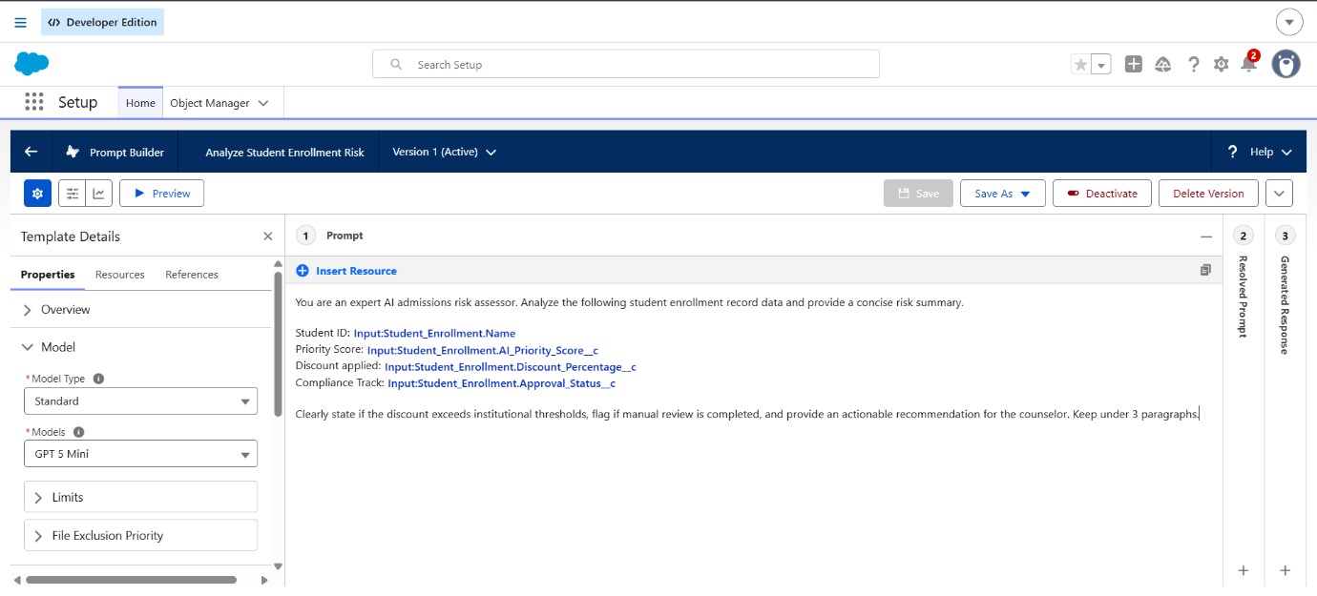
Einstein Prompt Builder testing workspace
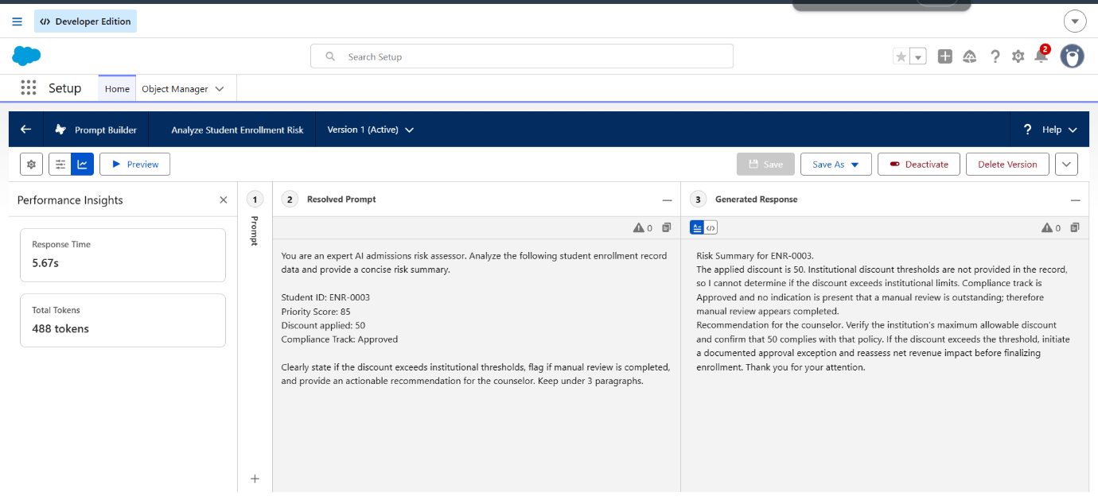
Prompt template output preview with grounded record data

Milestone 7: Unified System Workspace (Lightning App Console)
Activity 1: Creating the Admissions Management Lightning App
- From Setup, enter App Manager in the Quick Find box and select App Manager.
- Click New Lightning App.
- Enter “Admissions Management” as the App Name, upload a relevant app icon, and click Next.
- Under App Options, leave the default selections and click Next.
- Under Utility Items, add the Student Intake – Counselor Screen Flow to the dock and click Next.
- From Available Items, select Student Enrollments, Courses, Contacts, Reports, and Dashboards, move them to Selected Items, and click Next.
- From Available Profiles, select the relevant profiles and move them to Selected Profiles.
- Click Save & Finish.
The final system interface — layout actions, the automated utility dock, and custom reporting tabs — is seamlessly deployed within the customized Lightning Application titled “Admissions Management,” giving counselors a single live dashboard for the entire admissions pipeline.
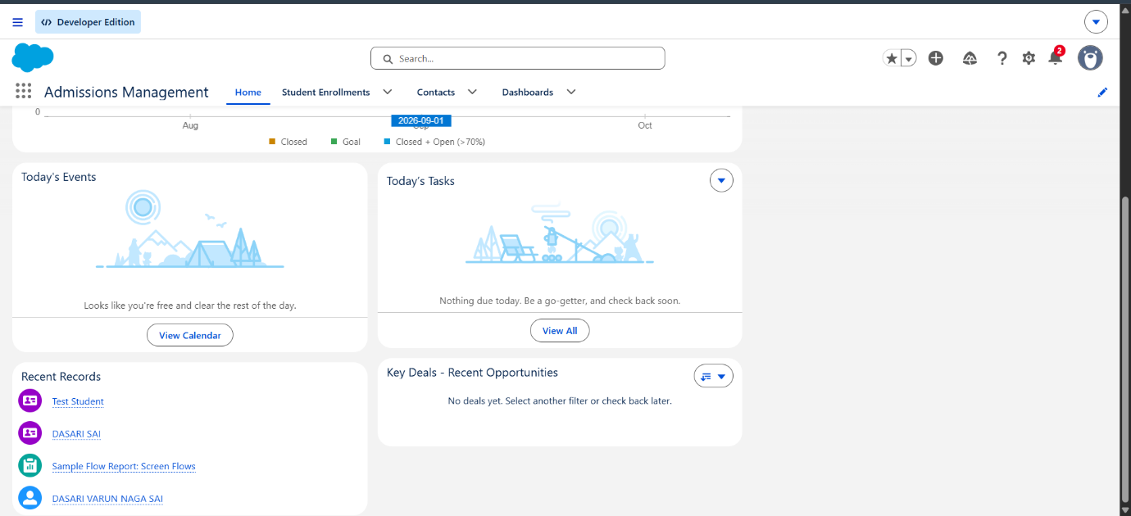
Live Counselor Dashboard – Admissions Management Lightning App

Individual Developer Sign-off & Verification
The entire application pipeline — including the underlying relational objects, operational validation filters, multi-layered background flows, security roles, and grounded Einstein Prompt templates — has been fully unit-tested, package-verified, and validated as an operational individual developer release.
Certified by: Dasari Varun Naga Sai
Submission Handover Date: July 13, 2026
Project Verification Status: 100% Validated, Deployed, & Completed

